SKEWED
A frequency distribution of the set of values that is not ‘symmetrical (normal)’ is called asymmetrical or skewed. In a skewed distribution, extreme values in a data set move towards one side, thereby lengthening that tail. When extreme values move towards the upper or right tail, the distribution is positively skewed. When such values move towards the lower or left tail, the distribution is negatively skewed.

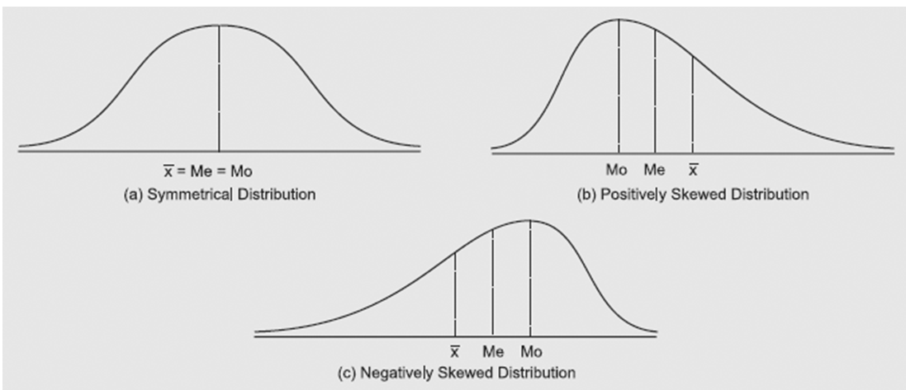

Measure of skewness is the statistical technique to indicate the direction and extent of skewness in the distribution of numerical values in the data set.
For a positively skewed distribution A.M. > Median > Mode, and for a negatively skewed distribution A.M. < Median < Mode.
The relationship between these measures of central tendency is used to develop a measure of skewness called the coefficient of skewness to understand the degree to which these three measures differ.

MEASURES OF SKEWNESS
The degree of skewness in a distribution can be measured both in the absolute and relative sense.
For an asymmetrical distribution, the distance between mean and mode may be used to measure the degree of skewness.
The mean is equal to mode in a symmetrical distribution.
Thus, Absolute S_{k} = Mean – Mode
= Q₃ + Q₁ – 2 Median (if measured in terms of quartiles).

Larger the difference between mean and mode, whether positive or negative, more is the asymmetrical distribution or skewness.

Relative Measures of Skewness
The following are three important relative measures of skewness.

Karl Pearson's coefficient of skewness
The measure suggested by Karl Pearson for measuring coefficient of skewness is given by:
Where S_{kp} = Karl Pearson's coefficient of skewness.
For a moderately skewed distribution the following relationship holds:
Mean – Mode = 3(Mean – Median) or Mode = 3 Median – 2 Mean
When this value of mode is substituted in the above eqn. we get
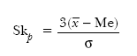
Theoretically, the value of Sk_{p} varies between ± 3. But for a moderately skewed distribution, value of Sk_{p} = ± 1. Useful in open end class intervals

Bowley's Coefficients of Skewness
Based on the relative positions of the median and the quartiles in a distribution. If a distribution is symmetrical, then Q₁ and Q₃ would be at equal distances from the value of the median,in such a case the absolute value of the coefficient of skewness will be zero.
Median – Q₁ = Q₃ – Median
or Q₃ + Q₁ – 2 Median = 0 or
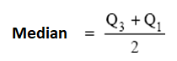
When a distribution is asymmetrical, quartiles are not at equal distance from the median.
The distribution is positively skewed, if Q₁ – Me > Q₃ – Me,
otherwise negatively skewed.
The absolute measure of skewness is converted into a relative measure for comparing distributions expressed in different units of measurement. For this, absolute measure is divided by the inter-quartile-range. That is,
In a distribution, if Med = Q₁, then Sk_{b} = ± 1, but of Med = Q₃ then Sk_{b} = – 1. This shows that the value of Sk_{b} varies between ± 1 for moderately skewed distribution.
This method of measuring skewness is quite useful in those cases where
- mode is ill-defined and extreme observations are present in the data,
- the distribution has open-end classes.
These two advantages of Bowley's coefficient of skewness indicate that it is not affected by extreme observations in the data set.
Remark: The values of Sk_{b} obtained by Karl Pearson's and Bowley's methods cannot be compared. On certain occasions it is possible that one of them gives a positive value while the other gives a negative value.

Kelly's Coefficient of Skewness
The relative measure of skewness suggested by Prof. Kelly is based on percentiles and deciles:

This method is an extension of Bowley's method in the sense that Bowley's method is based on the middle 50 per cent of the observations while this method is based on the observations between the 10th and 90th percentiles (or first and nineth deciles).

